
WINTER 2025
Issued 23rd November 2025
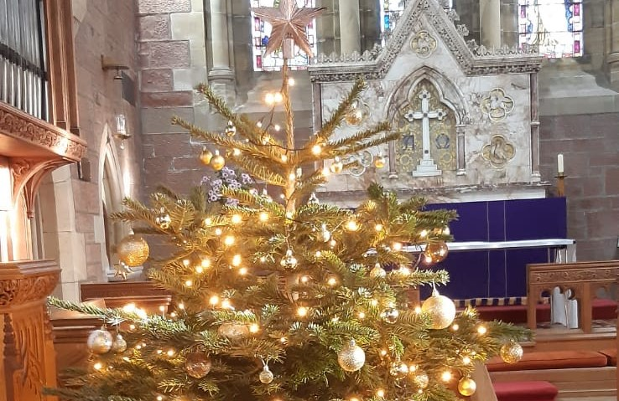

The Season of Winter
and Christmas Festival
The story behind the “the 12 days of Christmas” carol. Roman Catholics in England were not permitted to practice their faith openly from 1558 to 1829. Someone wrote this carol during that era as a catechism song for young Catholics. It has two levels of meaning - the surface meaning plus a hidden one known only to members of their church. Each element in the carol has a code word for a religious reality children could remember.
A partridge in a pear tree was Jesus Christ.
Two turtle doves were the Old and New Testaments.
Three French hens stood for “faith, hope and love”
Four calling birds were the four gospels – Matthew, Mark, Luke and John.
Five gold rings recalled the Torah or law contained in the first 5 books of the Old Testament. (Genesis, Exodus, Leviticus, Numbers, Deuteronomy).
Six geese a-laying are the 6 days of creation.
Seven swans a-swimming represent the sevenfold gifts of the Holy Spirit: (prophesy, serving, teaching, exhortation, contribution, leadership and mercy).
Eight maids a-milking were 8 Beatitudes. (poor in spirit, mourn, meek, hunger for righteousness, merciful, pure, peacemakers, persecuted).
Nine ladies dancing were the nine fruits of the Holy Spirit: love, joy, peace, modesty, patience (forbearance), goodness (kindness), mildness, fidelity (faithfulness), chastity (self-control).
Ten lords a-leaping were the Ten Commandments.(I am your God, there is no other, no images, taking the name of God in vain, keep Sabbath holy, honour father & mother, no murder, no adultery, no stealing, no lying, shall not want, house, wife/husband, belongings of neighbours).
Eleven pipers piping were the 11 faithful disciples.
Twelve drummers drumming symbolised the 12 points of belief in the Apostles Creed. (God creator and Father, Jesus our Lord, Jesus conceived by Holy Spirit, Jesus crucified, Jesus rose from the dead, Jesus ascended, Jesus will return to judge, Holy Spirit part of the Trinity, Church is universal, we will be resurrected, Communion of saints, sins forgiven

What’s on in this issue
Page 1 Meaning of 12 days of Christmas
Page 2 Editors notes, a message from Bishop Nick
Page 3 The rector’s letter, Church attendance,
Page 4 Stained glass in church / Poets corner
Page 5 Church, choir, Christmas
Pages 6 & 7 Christmas messages
Page 8 Memorial Garden tribute, Church hall roof status, We will remember them
Page 9 Memories of Winter
Page 10 Poem, Wot is, Life at St Columba’s
Page 11 Future services / events and other notices
Page 12Vestry details and key contacts
A note from the editor
I thoroughly enjoyed editing the Autumn and Winter magazines and thank you to all who gave editing suggestions or contributions. If you’ll have me, I am happy to carry on editing the magazine.

The COPY DEADLINE for the Spring edition of the church magazine is 15th February 2026.
Robin Spencer, Editor
How to contact me
Letters Holehouse Farm
Holehouse Road, Largs, KA30 8RL
Email: robin@shropshirelavender.co.uk
Social Media Whatsapp message me direct
(Robin Spencer on the mobile number below)
Telephone / text 07818 035789

What’s on in future issues
The next magazine will be the Spring issue, with a focus on the re-birth of nature, Easter and social issues related the end of darkness and the beginning of longer, brighter, warmer days.
Please email me a photo of your special Spring or Easter memories, with a brief explanation of what it means to you. .
The church WhatsApp group
St Columba’s Episcopal Church has a very active social media group on WhatsApp, where we share reminders, raise and answer queries, and broadcast information (such as progress on the church hall repairs).

If you wish to join the WhatsApp group, please message Hilary Moran on 07989 693410

NOTICES
Sheila Ferguson, a long-standing member of St Columba’s Episcopal Church, sadly died on Monday 27th October after a rather lengthy illness. She will be especially remembered for her kindly nature as well as her Easter candles and many floral contributions to adorn the church throughout the years.
Bishop Nick’s message

It's a great pleasure to write to the people of St Columba's, Largs, and to thank you for the warmth of your welcome as I've been settling into ministry in this beautiful part of Scotland. I've been struck by the vitality and generosity of our churches across the diocese - communities seeking to follow Christ faithfully and to serve their neighbours with love and imagination. It's also been a privilege to help your vestry with the vacancy process, and I look forward to seeing who God might be calling to be your new priest.

Our new diocesan vision is summed up in a simple phrase: The Diocese of Glasgow and Galloway, becoming a Church for Everyone. We want to be a church where everyone can find belonging, where faith in Christ is deepened, and where together we become the people God is calling us to be. Over the coming years we'll be helping each congregation discern its unique strengths and grow in health and confidence.

I know St Columba's has a strong tradition of welcome, worship, and service within the town. My hope is that, as we walk together in this new season, you'll continue to be a beacon of hope and hospitality for the wider community - a place where Christ's light shines out across the Firth of Clyde.

I keep hearing that you have some very good ice cream at Nardini's. I must stop limiting myself to evening vestry meetings at St Columba's and try it for myself!

With every blessing,
+Nick

Vestry Meeting - Snippets
- A new congregational roll has been created with personal info authorised by members.
- The vestry secretary has provided the Diocesan Office detail of St Columba’s relationships with other churches in Largs.
- All the cooks at our car boot sales have now achieved Stage 2 Food and Hygiene.

THE RECTOR’S LETTER

How the year has flown by and we come to the Christmas season again. We discover the shepherds and the wise men as spectators in this event. During my time in ministry it has been a delight to experience many school nativities and how innocent and often emotional they can be.

But perhaps this also needs us to look beyond the obvious and understand what is really going on because there is nothing mysterious about it as this is called faith. Faith sounds a terribly holy word but we exercise faith every day. Faith is simply putting your trust in something and God asks us in faith to look beyond the commercial grasp of the season. Rather concentrate on the little baby lying in a stable and see that here is a miracle. Here is the greatest expression of love that has ever, and will ever, be offered to humanity.

So let us this Christmas once again capture the truth and wonder in that stable to see it as the first place where Almighty God touched this blessed earth. Christmas blessings be with you all.
Sandy Montgomerie, Interim Rector

Looking for a new Rector
Applications for the position of Church Rector of St Columba’s Episcopal Church closed on Sunday 9th November. Only one application was received by the closing date, and Vestry therefore decided to readvertise the vacancy over the coming weeks to seek a bigger cohort of candidates.

The AGM
On Sunday 26th October, Treasurer, Chris Evans, gave a detailed presentation of St Columba’s Episcopal Church’s activities and finances for the past year. A major part of the report focused on the damages to church property caused by Storm Eowyn in January 2025 and the work / costs that subsequently have arisen, so we are especially grateful to the very generous legacy of over £70,000 from the late Kenneth Hinshalwood.

If you would like a copy of the Treasurer’s report, please contact Chris Evans directly.
Eucharist service attendance
In 1967, an average of 12 people attended the 08.00 Eucharist and 46 people (44 communicants) the 11.00 Eucharist (ref church mag Feb ‘67).
Attendance levels from 2015 to 2024, at the 08.00am and 11.00am Eucharist services (from the church register) clearly highlight the impact of the coronavirus epidemic. It excludes Wednesday Eucharist services, or other services associated with festivals such as Christmas, or weddings / funerals, which also attract many people, but includes attendances to the online ‘Service of the Word’ that was broadcast on 25 of the 33 Sundays when the church, together with all public buildings, was closed.

The 10 year period (2015-2024) contains 522 Sundays, during which 512 Eucharist services were held. No service was held on 10 Sundays, mainly during the coronavirus epidemic. Prior to the epidemic, an average of 41 people attended the 11.00 Sunday Eucharist service. This fell to an average of 24.7 and 21.9 during 2020-21, but has risen steadily since 2022, when churches were fully open for business, to 31.3 in 2024. Attendances to the 11.00 Eucharist continued to rise in 2025 (by 6% to 33.3 in the 10 months of January-October).

394 Eucharist services were held at 08.00am and no services were held (that the public could attend) on 128 Sundays, mainly due to corona virus restrictions. Despite this, attendance levels have remained steady, falling slightly from an average of 4.6 (2015-2019), to 3.9 in 2020, rising to 4.3 by 2024, up a further 21% to 5.2 in 2025 (Jan to Oct).
STAINED GLASS IMAGES OF ST COLUMBA
By James Willetts

Below are images of the stained glass in the West window or our church, together with some explanations of their meaning.
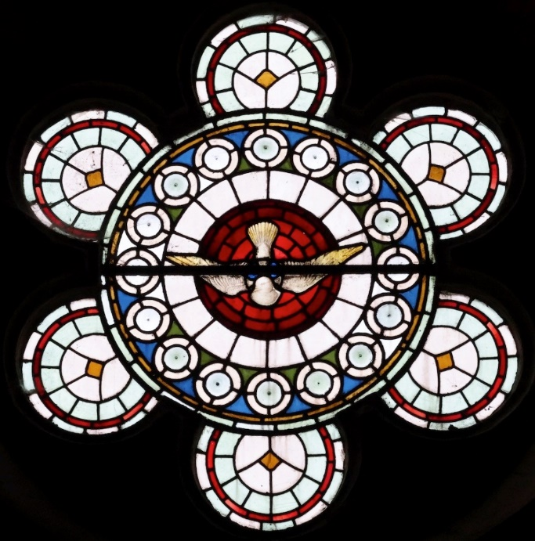 Columba is the Latin for ‘dove’ (a symbol of love)

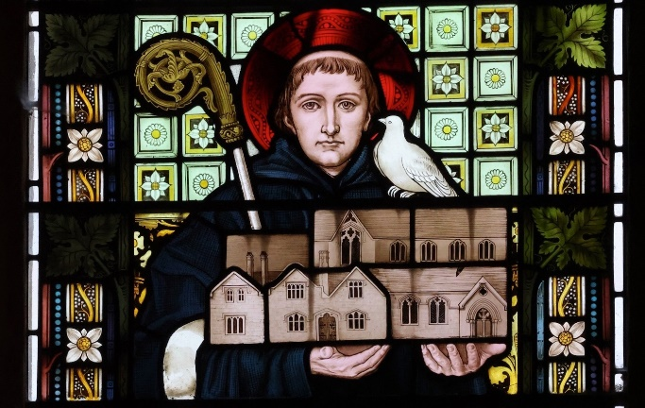 The Latin inscription beneath Saint Columba, who is represented as holding up the Church in his hands, can be translated literally as follows:
AUTEM = But. INQUIRENTES = those who seek. DOMINUM = the Lord. NON DEFICIENT = will not lack. OMNI = every. BONO = good thing / blessing.
Note that the ‘I’ of INQUIRENTES is not visible (hidden behind the horizontal lead bar above it).
Translated into modern English, this inscription may be expressed as follows:
But they who seek the lord will lack for nothing.
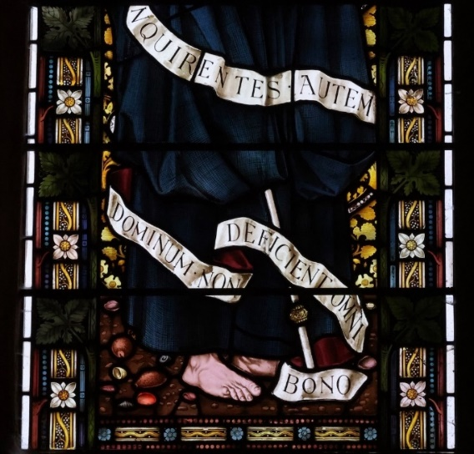
This quote is based on the Latin version of psalm 34, verse 22. Remarkably, this differs from the Hebrew and Greek originals, on which English translations are generally based (e.g. The Authorised Version reads: “The Lord will redeem the souls of his servants: and none of them that trust in him will be desolate.”) In contrast with the Hebrew and Greek originals, the Latin version, which is quoted in the west window of Saint Columba’s Church in Largs, is clearly a rather more positive and optimistic expression of faith.
POETS CORNER (anon)
From Canterbury the Tales began
Some bawdy that should not be told
And some were of a Winter’s tale
Of mystery, Myrrh and Gold

An infant born in a far off Land
Where angels sang loud “It’s a boy!”
Whilst snow lay deep on Scotland’s sod
And no one sang for joy

For hunger gnawed hard at the flesh
The crops had failed again
And death stood grimly in the glen
Patiently waiting in the rain

Christingle service
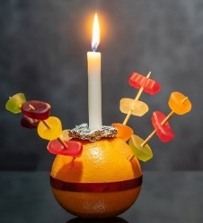
This year’s Christingle service at St Columba’s Episcopal church will be held at 4.00pm on Christmas Eve. It is a joyful service for children and adults, with the candle on a decorated orange representing Jesus as the light of the world.
CHURCH, CHOIR, CHRISTMAS

The choir and organ will be sounding out triumphantly at Christmas, after the promise of Advent. Some people find it easy to mix these two periods up; they wonder when the big, flashy carols will finally be sung, but we are in a waiting time, an expectant time when hymns such as “Come thou long expected Jesus” is quite normal for us to sing.
Christmas carols, as we now know them, were not quite the versions we sing today. Some date back hundreds of years, such as French and Flemish carols and some are truly Victorian, the tunes having been adapted from Europe, and many had originally been both danced and sung. Maybe we are missing a trick here! “ In Dulci Jubilo” or as we sing in modern times “Good Christian Men Rejoice”, although that phrase now reads “ Good Christians All, Rejoice”.
‘In Dulci Jubilo” dates from the early 14th century, exhorting Christians to rejoice and experience the sweetness of Christ; Interesting in that Europe was war torn and in the middle of a mini ice age. Did it have a “feel good factor” to get people rejoicing and dancing to dispel the freezing cold?
The year 1666 saw a momentous event; The Great Fire of London, but did you know that was when “I saw Three Ships Come Sailing In” was introduced, mostly by intimate singing groups in Germany. It seems somewhat of a nonsense to our modern sensibilities – three ships carrying Christ and His Lady mother all the way from the Holy Land to Germany – we really have to use our imagination for that one. Along the way the song came to express the Magi’s visit to the child Christ, and there is evidence (somewhere!) that supposed relics of the three Magi were brought to Germany and Flanders. It’s an interesting story.
The First Noel: Composed in 1823, it gained immediate popularity and is from Germany and France. The word “Noel” plays an important part; thought by some to be associated with the French “natale” or birth, the French actually associated Noel with the old German winter festival of “Neu Helle” or New Light. People longing for the light of the end of winter came to associate the two phrases or words. Longing for the end of darkness and the light of Christ have a distinct parallel.
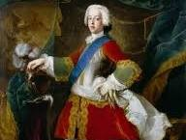
O Come all ye Faithful: now this carol, beloved of us all – we sing it joyfully on Christmas Eve – seemingly, and wait for it – has Jacobite associations! I could use up printing ink telling you all about a secret code in the text referring to Bonnie Prince Charlie, but I would be diving down the proverbial rabbit hole. Readers may choose to do so at their leisure!
I am sure the thought of our own newborn King is a much better and joyful sing at Christmas. There you have it folks, a wander through some of our Christmas music heritage. I feel we are all the better for our Christmas carols which root us in faith and wonder. Have a good Christmas all.
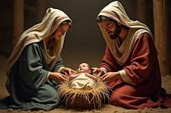
Colleen Anderson, Director of Music

"A merry Christmas to All" from Betty Ferguson
Ray and Linda wishing our Church family a blessed Christmas
and New Year
Christmas best wishes
from Alice MacDonald
Best wishes for Christmas and a good New Year, Fionna Fergusonx

May you all have a very peaceful & joyous Christmas. With love from our home to yours xxx Victoria and Tim Johnston
A very happy Christmas to you all with love from Hilary

Sending you the warmest wishes for a very Merry Christmas and health and happiness in 2026. Liz Kent

A happy Christmas to you all and a peaceful New Year. Stuart
Wishing everyone a very merry Christmas & and a happy new year!
Catriona xx
Wishing you a happy and healthy Christmas and New Year, with best wishes from Frances and Neil Robertson
A merry Christmas and a happy and peaceful New Year to all
from Esme and John.
Wishing everyone a happy and joyous Christmas and a peaceful New Year, Linda Whitby
Lord, may the peace and blessing of the Christ Child be upon all our families and may our love for each other reflect your own love for us. Peace and Blessing be with you all this Christmastide. Revd Martin & Freda Sofield
Frohe Weihnachten, Buon Natale Joyeux Noel, Feliz Navidad
καλα χριστουγεννα
Prayers and blessing for this Christmastide and for the new opportunities that 2026 will bring to you at
St. Columba’s!
Mark and Gwen
Jean
Christmas greetings from Edward, MengMeng
and Baby Eleanor Spencer
Joy and peace this Christmas to you and yours.
Jen B
Linda and David Miller wish everyone at St. Columba’s a happy and peaceful Christmas, and thank you for the warm welcome we received

Christmas greetings to all from Gib & Jennifer
Happy Christmas to all and best wishes for the New Year
From Chris and Jane
Wishing everyone a merry Christmas and a peaceful and happy New Year
From John and Jean
Warm wishes to all for a happy Christmas and a peaceful New Year
from Joan Hutton
Seasons greetings to all
from Colleen and Gregor
May the hope of Christmas lighten your cares, the peace of Christmas fill your heart,
the joy of Christmas bring you happiness, the spirit of Christmas remain with you all year.
Sandy Mongomerie
Happy Christmas all
from Robin and Joanna

Warm wishes for a very Happy Christmas
Elspeth Robertson
A peaceful and blessed Christmas to everyone
from Irene
Memorial Garden tribute
By Mark Yeomans
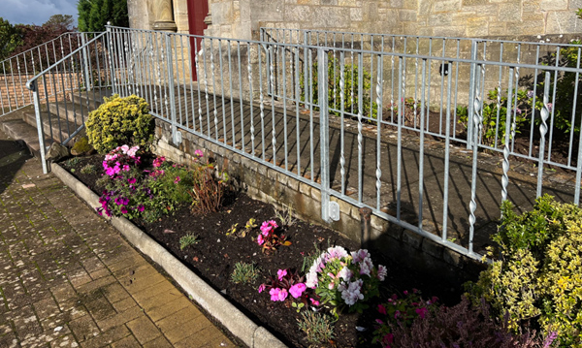With autumn now well upon us, I would like to extend my heartfelt thanks to all church members who have generously given their time and effort on Saturday mornings to assist with the renovation of the Remembrance Garden.
Your dedication, teamwork, and community spirit have been truly inspiring. The progress we have made would not have been possible without your willingness to lend a hand, share your skills, and support this meaningful project.
The Remembrance Garden now stands as a testament to our shared commitment and care. It offers a place of solace, reflection, and remembrance for all who visit. The improvements made have not only enhanced its beauty but have deepened its significance for our congregation and the wider community, providing a peaceful sanctuary where memories can be honoured and new friendships can blossom.
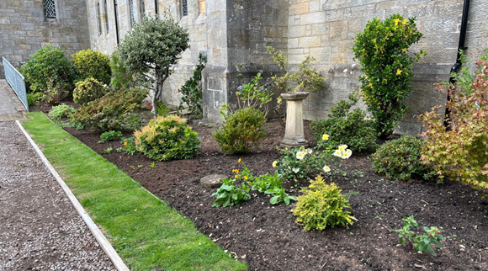In the spirit of building on this wonderful progress, we are delighted to announce a fundraising initiative to sponsor a new composite wood and resin two-seater bench for the Remembrance Garden. This addition will further enhance the comfort and accessibility of the space for everyone. The total cost of the bench is £250 (constructed and delivered), and we kindly suggest a donation of £25 or more from those who wish to support this endeavour. Should our fundraising efforts exceed the target, we hope to install a pergola, offering additional shelter and beauty for the garden.
If you would like to contribute, please contact Linda Young 07709 880496. Donations can also be made in person at the church in an envelope - please reference “Remembrance Garden Bench”.
The sad tale of the hall roof
10 months after the damage caused by Storm Eowyn in January, the Church Hall roof is finally watertight and the interior is drying out. Work has commenced on the repairs and restoration. Most of the repair work is covered by the insurance policy, but there is a significant sum to be met by church funds, possibly in the order of £30,000.

It has been a very sad, drawn-out affair, but happily the light at the end of the tunnel is shining bright, and we will be using our beloved church hall again early in the New Year.

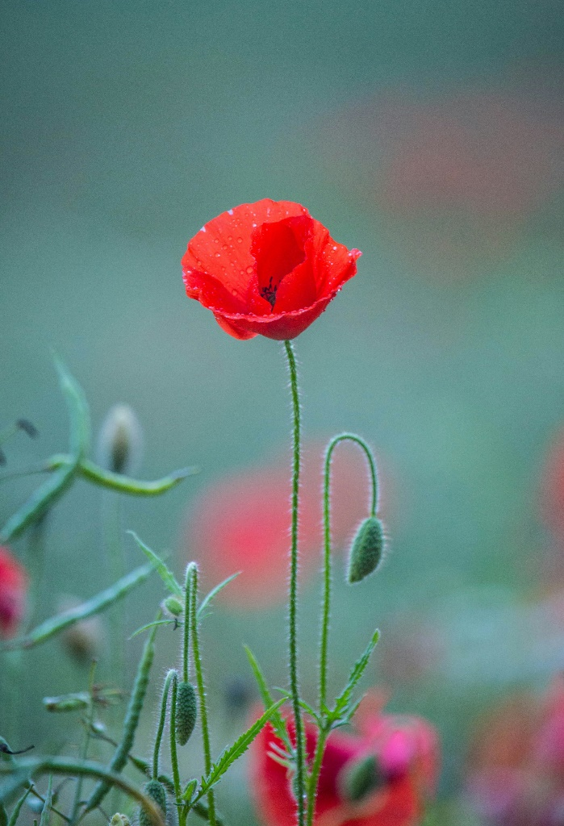
We Will Remember Them

WORLD WAR I
Capt the Hon James Boyle, Royal Scots Fusiliers
Pvt George Webster Hunter. Royal Scots Fusiliers
Lt/Cpl George James Stewart MacDonald, Cameron Highlanders
Pvt Daniel McGhie Highland Light Infantry
Gunner Robert D McKennie Regiment unknown
Cpt Maximillian McPherson Seaforth Highlanders
Lt Charles Tennant Seaforth Highlanders

WORLD WAR II
Commander JA Binnie Royal Navy
Capt The Hon PJ Boyle Scots Guards
Maj John McKay Ferguson PAVO Cavalry
Col Graham T Lyall VC Canadian Expedition Force
2ND Lt Donald Bourbon Lyall Royal Artillery
Capt Donald Graham Napier A&S Highlanders
F/O Ian Holdsworth Robertson RAF VR
Fl Lt William Alistair Mclean Stewart RAF VR
Lt Desmond Vaughan Wilkinson RA
Bugler Douglas Ernest Woods Cameronians
Lady Grizel Wolfe Murray VAD

For further information see the magazine insert
Memories of Winter
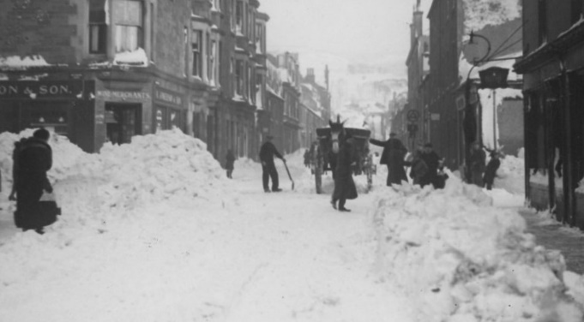
Largs – 1940. For many, the quintessential image of winter is deep snow, like Largs High Street in the photo. There have been deep snow falls since, notably 1947 and 1963. But as global warming gathers momentum “I’m dreaming of a White Christmas” will remain just a distant memory, a forlorn hope “Let it snow, let it snow, let it snow”.
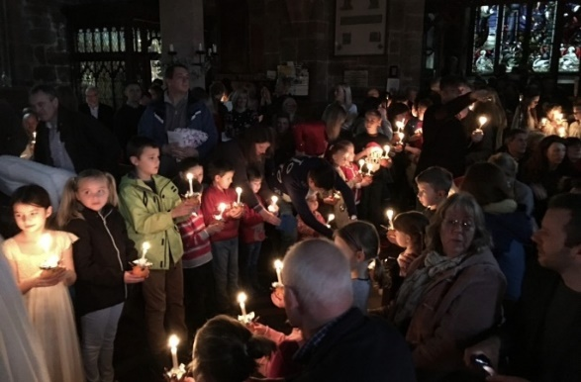
Christingle 2014 – the magical innocence of young faces singing “Away in a Manger” by candlelight.

Christmas when I was 9
Pre – Christmas were the school and Boys Brigade parties. From Primary 5 (up to 6th form) PE lessons leading up to the season would consist of Scottish Country dance lessons. This would prepare you for your year group party with dances and jelly and ice cream. Presents would be made in class for your parents (usually completely useless things) and Blue Peter would instruct you in making Christmas spectaculars.

My father was a Religious Broadcasting Producer with BBC Scotland Radio and he would leave the house early on Christmas day to produce a service from Quarriers Village in Bridge of Weir, so I didn’t see him until nearly lunch time.

As a 9-year old son of the Manse, Christmas revolved around church - school, Sunday School, and Lifeboy services. At some point, a visit to cousins would be arranged, which I dreaded as I suffered from travel sickness every time!
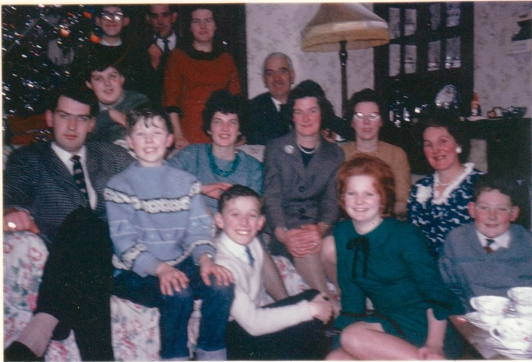 Can you spot Gregor Anderson in the photo?

Lunch was the usual family affair in the dining room – reserved for special occasions! Turkey (ripped-not carved by dad) and mum’s home made stuffing, now called “skirlie”. Presents would be opened after lunch. The exception to this would be the tradition of opening one present when you woke up and opening your “stocking”. Mum had the habit of carefully unwrapping presents, folding the paper and using it again the next year! When I was nine, I got Scalextric. I was rarely without this even after I got married, when we made a huge layout with the kids. In 1964 it snowed at Christmas. The next year I got a sledge as a present – it didn’t snow.

TV was allowed after lunch. The Queen’s message would be watched and then there was usually a Circus. With only two channels to choose from we were limited and, with dad working for the BBC, we were steered towards that channel.
Christmas viewing revolved round the Radio Times. Issued free to BBC employees, of course.

On the weeks leading up to Christmas, there would be a visit by tram to the Kelvin Hall in Glasgow for the Circus. The smell of elephants still lingers. There would also be the trip into the city to see “Santa”. This involved a steam train journey into Glasgow and a walk through George Square to Lewis’s department store, accompanied by the raucous starlings which inhabited Glasgow centre at that time. When you got to Lewis’s, you climbed a staircase which had displays (elves, toyshops, automata) on the landings till you reached Santa’s grotto. I remember getting a Sooty Xylophone one year. A magic time. Then chips and back on the train.

Which way do YOU read this?

Reading the poem DOWN is very sad.

They have no need of our help
So do not tell me
These haggard faces could belong to you or me
Should life have dealt a different hand
We need to see them for who they really are
Chancers and scroungers
Layabouts and loungers
With bombs up their sleeves
Cut-throats and thieves
They are not
Welcome here
We should make them
Go back to where they came from
They cannot
Share our food
Share our homes
Share our countries
Instead let us
Build a wall to keep them out
It is not OK to say
These are people just like us
A place only belongs to those who are born there
Do not be so stupid to think that
The world can be looked at another way.

Read the poem UPWARDS – it’s very uplifting

WOT IS – EPISCOPAL?
An Episcopal Church is a church with bishops as the chief local authorities, following a hierarchical structure known as episcopal polity. The Episcopal Church worships in the liturgical style, which means all Episcopal churches follow a similar order of service. The term comes from the Greek word “episkopos”, meaning "overseer.

Donations to charities

Money raised by St Columba’s Episcopal Church from car boot sales and social events went to the following charities:
Survival of Bereavement by Suicide - £540
Glasgow and Clyde Rape Crisis - £540

Life at St Columba’s

Director of Music
Colleen Anderson 07967 114624

Property Convenor
Mark Yeomans 01475 520296

Fundraising Committee
Hilary Moran 01475 686213

Protection of Vulnerable Groups Co-ordinator
Victoria Johnston
Mother’s Union
Hilary Moran 01475 686213

Church Hall Convenor
Linda Young 01475 686241

Church Flowers
Joan Hutton 01475 672927

Sidesmen
Alice MacDonald 07833 120400

Christian Aid
Alice MacDonald 07833 120400
Reps on inter-church Christian Aid Committee

Intercessions Rota
Frances Robertson 01475 686947

Altar Servers
Alice MacDonald 07833 120400

Readers Rota
Gib FitzGibbon 01294 823992

Coffee Rota
Jennifer FitzGibbon 01294-823992

Largs Churches Together
Alice MacDonald 07833 120400

Press Officer
Hilary Moran 01475 686213

Health and Safety Officer
Alice MacDonald 07833 120400

Baptism, Wedding, Funeral, Confession by arrangement with the Rector

Pastoral Visitors in the congregation
Rector (to be appointed), Alice MacDonald, Linda Whitby and Armorel Allen

For more information on responsibilities, see the notice board in the church entrance.
CHURCH SERVICES
AND FUTURE EVENTS
Weekly Services
Sunday
8.00 am Holy Communion
11.00 am Sung Eucharist

Wednesday
10.00 am Holy Communion

29th November Taize (this service starts at 3.30pm with the main Taize service at 5.00 pm)

December
14th December Nine lessons and carols (5.00pm)
24th December Christingle Service (4.00 pm)
24th December Midnight Mass (11.00 pm)
25th December Holy Communion (10.00 am)

January
4th January Service of the Chalk / Lunch after
4th January Taize (5.00 pm)
25th January Service Christian Unity (St Mary’s)

February
1st February Candlemass (5pm) / refreshments

1st March Taize (5.00 pm)

Harvest Festival Lunch
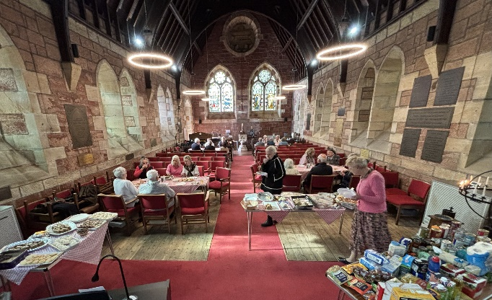
Over twenty members of the congregation enjoyed a lovely Harvest Festival Lunch in church, as the hall is still not fit for use - 7 months after storms damaged the roof! A huge thank you to everybody involved in providing such a wonderful feast, despite the challenging circumstances!
The Scottish Episcopal Church


The Scottish Episcopal Church is a self-governing province of the world-wide Anglican Communion.

This is a family of over 70 million Christians in more than 160 countries. Our nearest relations are the Church of England, the Church of Wales and the Church of Ireland. Through the Porvoo agreement we are also in full communion with many other branches of the Church.

St. Columba’s in Largs, is one of over 60 Episcopal congregations that work and worship within the Diocese of Glasgow and Galloway. We are part of Ayrshire Region and our neighbours include congregations in Ardrossan, Dalry, Troon, Kilmarnock, Prestwick, Ayr and Maybole.

The area covered by St. Columba’s includes Largs, Skelmorlie, Fairlie and West Kilbride. Ecumenically we play a very active part in Largs and District Churches together. We welcome all regardless of any defining characteristic that may otherwise be used as the basis for discrimination.

Church Rotas

If you would like to join one of the church rotas (Readers Rota, Intercessions Rota, Sidesman Rota or the Coffee Rota), please contact :

Readers Rota – Gib FitzGibbon 01294 823992
Intercessions– Frances Robertson 01475 686947
Sidesmen – Alice MacDonald 07833 120400
Coffee - Jennifer FitzGibbon 01294 823992
Email – i2fg@aol.com
St. Columba’s Episcopal Church
Aubrey Crescent, Largs
Interim Rector: Sandy Montgomerie
St. Columba’s Church, Largs
Telephone – 07950 737277

The Vestry
The vestry members are elected by the congregation to work with the Rector for the administration of the church. It meets in January, March, September, November and as required.
Chair – Sandy Montgomerie
Secretary – Ray Young
Treasurer – Chris Evans
Lay Representative – Gib Fitzgibbon
Alternate Lay Rep– Hilary Moran
Rector’s Warden – Linda Young
PVG Co-ordinator - Victoria Johnston
People’s Warden – Alice MacDonald
Property Convenor – Mark Yeomans
IT Services - Gregor Anderson
Members - Linda Whitby, Jane McCance and Thomas Parker
Scottish Charity Number – SC004796

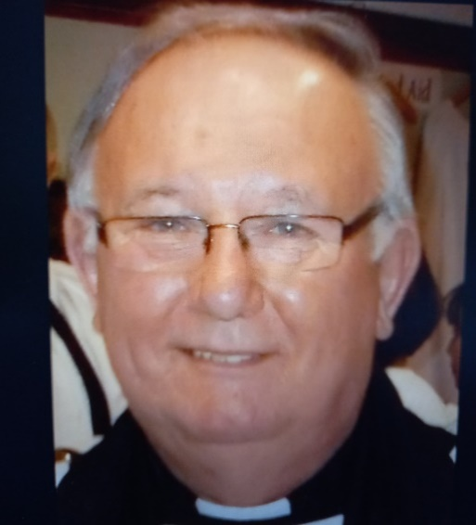
A warm welcome to the Reverend Canon, Sandy Montgomerie, recently appointed as Interim Rector of St Columba’s
The church magazine is printed and published by St. Columba’s Episcopal Church, Aubrey Crescent, Largs, KA30 8PR. The views expressed in this magazine are not necessarily those of the Rector or the Vestry. If you know of anyone who cannot access the online version at https://largs-church.co.uk/magazines or collect it from church, we can arrange for a copy to be sent to them.
Diocese of
Glasgow and Galloway
49 Cochrane Street, Glasgow G1 1HL
0141 221 5720

Diocesan website:
http://glasgow.anglican.org

Key contacts

Bishop
The Right Reverend Dr Nick Bundock
bishop@glasgow.anglican.org

Bishop’s Personal Assistant
Alexis Costigan
alexis@glasgow.anglican.org

Enquiries regarding property matters
usual days Monday to Wednesday
Janet Chalmers
janet@glasgow.anglican.org

Enquires regarding Finance
usual days
Monday, Wednesday, Thursday, Friday
Iolanthe Stack
iolanthe@glasgow.anglican.org

Diocesan Secretary & Treasurer
Susan Burr
diocesansecretary@glasgow.anglican.org

Director of Diocesan Operations
Kim Schmulian
usual days
Monday, Wednesday, Thursday, Friday
da@glasgow.anglican.org

Autumn fundraising
The following net amount was raised by members of St Columba’s Episcopal Church.

August £1,753.84 Car boot sale

