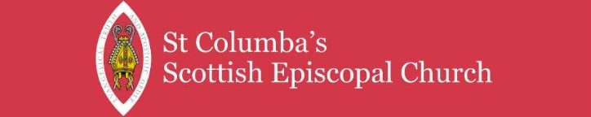
AUTUMN EDITION 2026
Issued 30th August 2026

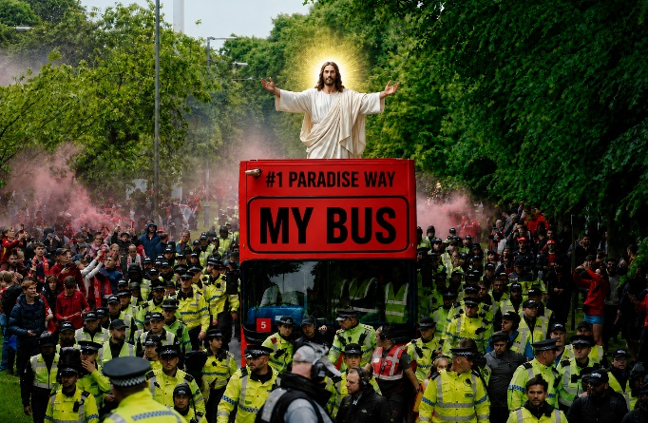

WHAT BUS ARE WE ON?

In an episode of Mrs Brown’s Boys, Father Quinn is lamenting how many of his parishioners are being converted to another denomination, and Mrs Brown says “We’re all heading for the same place – who cares what bus we’re on”, and the priest expostulates “I care!”. As we at St Columba’s embark on a new phase in our journey, with a priest from the Episcopal Church of the USA, some members might worry that we’re getting on a different bus. The following potted history (sources on the internet) might help to show how intertwined our stories are.

Prior to 1534, the English church was in communion with the (Roman) Catholic Church. The Church of England emerged from a dispute King Henry VIII had with Pope Clement VII, who refused to annul his marriage to Catherine of Aragon, because she had failed to produce an heir for him. Catherine was the aunt of Charles V, Holy Roman Emperor, and the Pope delayed the verdict amid political pressure from Charles. Henry became impatient with the delay, and secretly married Anne Boleyn in 1532. Thomas Cranmer, the archbishop of Canterbury, declared Henry's marriage to Catherine to be null and void, but the Pope formally rejected this and maintained that Henry was married to Catherine, and excommunicated Henry. The result was the Act of Supremacy 1534, which established the English monarch as Supreme Head of the Church of England. The English Reformation that followed attempted to develop a centralised religious identity in England and Ireland. This was all taking place in a context where Martin Luther had been challenging various aspects of papal authority, and William Tyndale had published the New Testament in English, removing the church’s monopoly.

The Reformation in Scotland began with the introduction of Tyndale’s Bible into the country in 1525. George Wishart, a parish priest in Montrose who had been influenced by John Calvin, was martyred for introducing people to the Bible, and the Reformation continued under John Knox. In 1560 the Scottish Parliament removed the Pope’s authority in Scotland and the General Assembly of the Church of Scotland was formed with “Superintendents” replacing Bishops. In 1572 the episcopate was restored, although bishops were now appointed, rather than consecrated and were subject to the General Assembly.

. . . . . . . . . . . Continued on page 3

What’s on in this issue

Page 1 What bus are we on?
Page 2 New Priest in Charge writes, Editors notes
Page 3 What bus are we on / continued
Page 4 Patron Sunday, miscellaneous
Page 5 Early Saints Pilgrimage to Bute
Page 6 Car boot Sale in July
Page 7 Introducing . . . . . . . . . + Poet’s Corner
Page 8 Blast from the Past, Justice & Peace Group
Page 9 250 years ago across the sea
Page 10 Life at St C, new anthem, James W reflects
Page 11 Future services / events and other notices
Page 12 Vestry details, contacts, Sean’s licence

New Priest-in-Charge writes
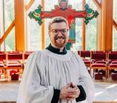
A New Beginning
It is a great joy to write to you as the newly installed Priest-in-Charge of St. Columba's. Lance and I have been so warmly welcomed into this community, and we are deeply grateful for the kindness, hospitality, and good humour that so many of you have already shown us. We are still finding our way around, learning names, discovering favourite places, and working out where everything is (most of our belongings are still in boxes on the Atlantic!), but we are already beginning to feel at home.

One of the things I have been thinking about in these first weeks is the simple truth that ministry is something we do together. St. Paul writes, "We are fellow workers for God" (1 Corinthians 3:9). That seems a good description of what lies ahead for us: not the priest doing ministry for the people, or the people doing ministry for the priest, but all of us discovering together what God is calling St. Columba's to be and to do in this place.

I am looking forward to getting to know you - not only through worship and parish activities, but also through ordinary conversations and encounters that make up the life of a community. I am always happy to meet for lunch or tea, and I would be delighted to hear about your life, your experience of St. Columba's, the things you love about this parish, and the hopes you have for our future.

And please feel free to call me "Father Sean" or simply "Sean." Either is perfectly fine! More importantly, please do reach out. If you have a pastoral concern or simply want to get together for a conversation, I would be glad to hear from you.

As we begin this new chapter, I am reminded of the disciples' simple invitation in John's Gospel: "Come and see." There is something wonderfully open-ended about those words. They are an invitation to curiosity, relationship, and discovery. I hope that, in the months and years ahead, we will continue to come and see together: to see where Christ is already at work among us, to see where the Spirit is calling us, and to discover how we might share the good news of God's love with one another and the wider community.

Lance and I are grateful to be here. We are grateful for the welcome you have given us, and we look forward to all that lies ahead. I look forward to meeting you, listening to you, worshiping with you, and sharing in the life of this community. May God bless St. Columba's, and may God bless the journey we are beginning together.

In Christ, Fr. Sean+

A note from the editor
I welcome any articles, news items, information or poems that are important or special to you. The COPY DEADLINE for the Winter edition of the church magazine is 15th November 2026.

Robin Spencer, Editor
How to contact me
Letters Holehouse Farm
Holehouse Road, Largs, KA30 8RL
Email: robin@shropshirelavender.co.uk
Social Media WhatsApp message me direct
(Robin Spencer on the mobile number below)
Telephone / text 07818 035789

What’s on – this/future issues

As this summer we will be celebrating the 150th anniversary of the founding or St Columba’s Episcopal Church in Largs, there are several articles on the subject from different sources. Enjoy!

With vestry approval, I am interviewing members of the congregation, with an aim to collate a short biography of members of St Columba’s SE Church, so that we can all have a better idea who our fellow church members are. The biographies will be available in printed and / electronic format in due course. Personal details / info discussed is only published following interviewee text approval.
WHAT BUS ARE WE ON / continued from page 1

In 1592 Presbyterianism was established as the Church of Scotland although bishops continued to sit in parliament until 1610 when episcopacy in Scotland was restored at the Assembly of Glasgow and three bishops were consecrated in London, returning to consecrate other bishops. However, opposition to the king and the newly re-established episcopalian Church of Scotland continued. King Charles I, with the approval of Archbishop William Laud, introduced a Book of Common Prayer for Scotland in 1637. It was rejected by the Church of Scotland, and episcopacy was again abolished in 1638 and restored in 1661. By then only one of the Bishops remained alive, and four new Scottish bishops were consecrated in Westminster Abbey. They returned to Scotland and within six months consecrated a further eight bishops. The 1690 Act of Assembly by the Parliament of Scotland officially re-established the Church of Scotland as a Presbyterian body, ratified the Westminster Confession of Faith and dismantled episcopacy.

However, the Apostolic Succession (the tradition that Bishops have passed on physical contact in an unbroken chain back to Jesus) had been preserved, and over the next 60 years, the Episcopal Church developed separately from the Church of Scotland, creating a Code of Canons. It established areas of episcopal authority and took as its Prayer Book the old 1637 Scottish Book of Common Prayer so that by the mid to late 18th century forms based on this book were in common use. Because Episcopalian clergy had refused to swear allegiance to William & Mary in 1689, maintaining that their oath of allegiance to James VII/II, was still valid, the church suffered severe political suspicion and legal penalties. In 1792 penal statutes against Scottish Episcopalians were finally repealed after they formally acknowledged the Hanoverian monarchy, allowing the church to organize as an independent denomination.

Anglicanism accompanied the expansion of the British Empire, with the colonial churches under the jurisdiction of the bishop of London. In the run-up to the American Revolution (1775–1783), the American colonialists, including Anglican priests, divided between Patriots and Loyalists. Anglican loyalists thought the church should be strengthened by an American bishop, but republicans fiercely opposed an Anglican bishop in America. About 27 percent of Anglican priests nationwide supported independence. After Congress adopted the Declaration of Independence on July 4, 1776, several states passed laws making prayers for the king and British Parliament acts of treason.

By the end of the Revolution, the Anglican Church was disestablished in all states where it had previously been a privileged religion. Having lost their connection with the Church of England, Anglicans were left without organization and an episcopacy. In 1782, an outline for organizing a national church that included both clergy and laity in its governance was published, and in 1783, ten Connecticut clergy elected Samuel Seabury as their prospective bishop. Seabury sought consecration in England, but the requirement for bishops to swear allegiance to the Crown made this impossible, so he went to Scotland where the Scottish bishops consecrated him in Aberdeen on November 14, 1784. He was urged to take as the basis for the American Episcopal liturgy the 1637 Scottish Book of Common Prayer. Seabury returned to Connecticut in 1785, and the first General Convention of the Protestant Episcopal Church in the United States of America drafted a constitution, and an American Book of Common Prayer based on the Scottish Book.

In 1787, two priests were consecrated as bishops by three Church of England bishops, thanks to the Consecration of Bishops Abroad Act 1786. In 1789, representative clergy from nine original dioceses met in Philadelphia to ratify the American church's initial constitution, and the Episcopal Church was formally separated from the Church of England so that American clergy would not be required to accept the supremacy of the British monarch. The 1637 Scottish Book of Common Prayer can be seen as a direct ancestor of the American Book of Common Prayer - particularly with regards to the Communion Service.

While Father Quinn might not approve of our bus, I think we can be reassured that we’re still on the same one!

Written by Gib FitzGibbon (using internet sources)
Patron Sunday
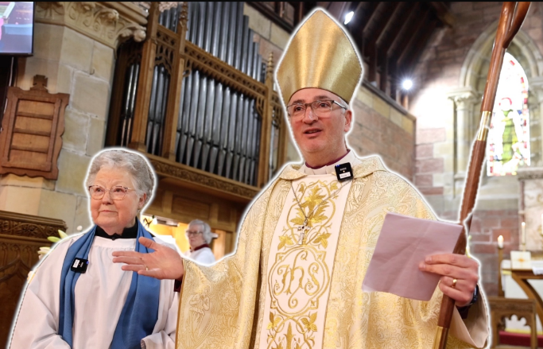
On Sunday 6th June we celebrated our patronage Sunday with a communion service dedicated to St Columba to start the celebrations of the 150th year of the foundation of St Columba’s Episcopal Church in Largs. We were blessed with the presence of our Bishop, the Rt Reverend Nick Bundock, who led the Eucharist service. His mantra is that the Christian Church is both prayer and party – today we will do both!

During his inspirational sermon, Bishop Nick reminded the congregation we are very lucky to be able to celebrate FIVE things all at the same time.

First, the patronal Festival. Second, the 150th Anniversary of the foundation of St Columba Church. Third, the re-dedication of the church organ. Fourth, the re-dedication of church hall, now fully repaired after the storm damage in January 2025. Fifth, appointment of a new priest.

He also told two stories about St Columba, one involving a Crane and one a white horse – his point being as much as we are looking forward to Sean arriving and caring for us, we should not forget that Sean may himself have needs. We have a community of mutuality, so we should look after him so that he and Lance can both thrive here.

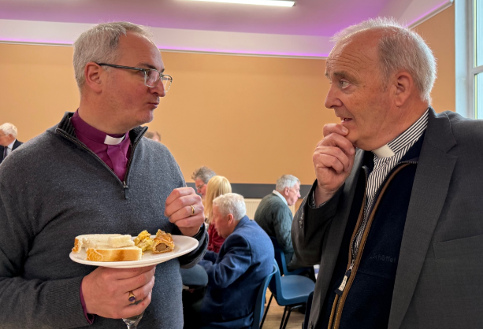
After the service, the Bishop joined the congregation in the renovated church hall, which he re-dedicated with a prayer, and together we partied. It wonderful to see Mark, our last rector, looking so well and joining in our celebration.

The church WhatsApp group
St Columba’s Episcopal Church has a very active social media group on WhatsApp, where we share reminders, raise and answer queries, and broadcast information (such as progress on the church hall repairs).

If you wish to join the WhatsApp group, please message Hilary Moran on 07989 693410

Treasurer’s tales
Over 550 people attended the Car Boot Sale at St Columba’s in glorious sunshine on Saturday July 18th, raising a total profit of £1,817.10!

Blessing of Animals Service

Saint Francis of Assisi was made a saint in the Roman Catholic Church in 1226 by Pope Gregory IX and his feast day is 4th October. He is honoured on this day throughout the world and by all Christian denominations. St Francis preached that the world and everything in it was created good and beautiful by God and that it is the duty of all creation to praise God and for us to protect and enjoy nature as both stewards of God’s creation and as creatures ourselves.

Our service will be on Saturday 3rd October at 2pm in the church to which all animals and their humans are invited. Refreshments will be served, both animal and humankind, after the service in the hall behind the church. There will be a collection plate at the back of the church, and any money donated will go to the SSPCA.

Vestry Meeting - Snippets
- Vestry approved £370 for sanding and lacquering the choir stall parquet flooring
- Vestry approved WhatsApp Guidelines Church Group – keep messages relevant, respectful / considerate and Christ-centred
- The hourly rate to use the church hall will be increased from £20 to £26 (on 01/09/2026)
- Congregational AGM will be held on Sunday 25th October. Please submit any activity reports to the Secretary by 4th October.

Early Saints Bute Pilgrimage
Saturday 13th June

In the early hours of Saturday morning on the 13th June, a dozen hardy souls arose and took the nine o’clock ferry to Bute, where they met with Hilary Moran, Jane McCance and Alice MacDonald (who had stayed overnight on the island) at the Coffee Store for a good strong cup of coffee. Fortunately, the rain that was forecast did not materialise, and we were blessed with a bright, albeit breezy day.

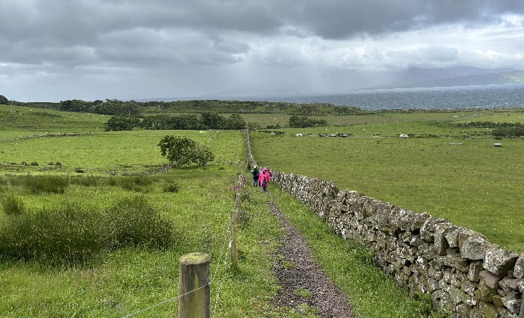After a short drive south, we disembarked at the beginning of the half mile cross country track to the ruins of St Blane’s Chapel, where the reverend Mark Batchelor, had already set up a table and communion sacraments for our service to celebrate the life of our church’s patron Saint, Columba. It really was a beautiful service, in the open air yet well sheltered by the four walls of the roofless church. Views of open countryside and the sea stretching away to the South. Small birds twittering and chirruping in the trees added a pleasant harmony to the hymns we sang.

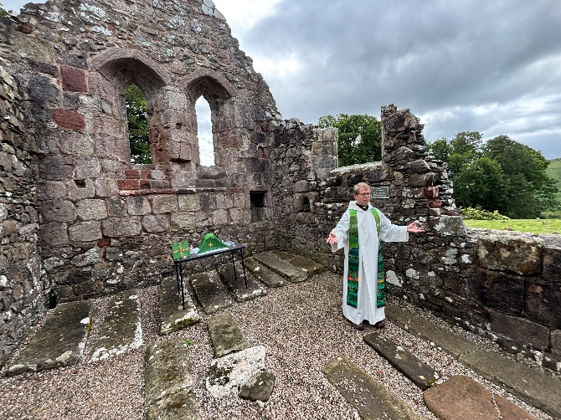

After the service, we drove about two miles to the Kingarth Hotel, where we met up with our speaker, Susan Hothersall, and enjoyed a pleasant meal together. With all the tables cleared away, we all enjoyed an interesting talk, starting with St Blane’s story, being banished to Ireland with his mother, then returning to Bute to establish a monastery. We then learnt about archaeological discoveries on Inchmarnock of carved slates, some of which are now in the Bute Museum. We were also shown many slides identifying the locations of ancient chapels and early churches connected to saints, including St Columba, although he was clearly not the first to bring Christianity to Scotland. Despite the paucity of documentary evidence, our speaker, Sue, had clearly put a lot of hard work into researching early saints, although she admits there is still a lot more to learn.

After a short tea break, Mark then led the final session, which was a private contemplation of the saints to find one that could make an impact on one’s own life. Amongst the saints that were mentioned, were Saint Francis, Saint Theresa and Saint Margaret of Scotland. Robin’s preference was for a saint renowned for ‘Patience’, but as his knowledge of saints is somewhat limited, he resorted to the internet and found that St Monica was the very one.

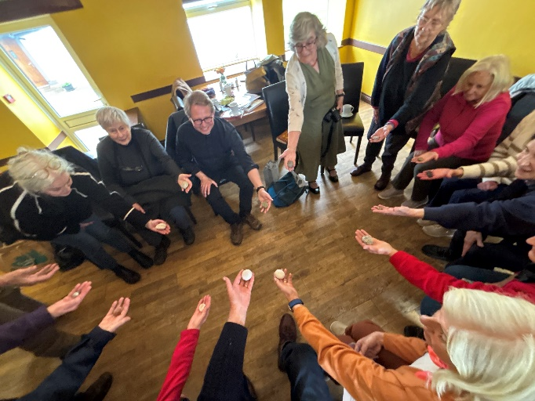

Mark also let us all choose a stone from a basket that he passed round. He had ‘borrowed’ the stones from St Columba’s Bay on the island of Iona, where our patron saint lived for many years. To assuage Mark’s conscience, we were all charged to return our stone to the beach on Iona, to rejoin its companions (should we ever visit the island).

On behalf of the group, I would like to offer our sincere and warmest thanks to Hilary, Mark and Susan for the hard work they put in to create a very enjoyable and memorable day for us all.
The car boot sale in July

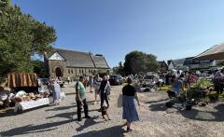
On Saturday 18th July, St Columba’s Scottish Episcopal church in Largs held its 3rd car boot sale of the year in the church grounds. This time, the weather was perfect – wall to wall blue skies. Over 45 cars and trading tables were taken, and hundreds of people from far near, 550+ in fact, came and supported the event.
Apart from the many diverse stalls, ranging from bric-a-brac and jewellery to vinyl records, plants, carpenters’ tools and much more, there was also an abundant supply of the legendary bacon sandwiches, cakes and biscuits, served in our recently renovated church hall, which added to the carnival-like atmosphere outside.
Looking back at past issues in the 1960’s and 70’s, it is interesting to note that the traditional church summer fetes are no longer held, but in terms of fund raising, they have be more than adequately replaced by four once a month car boot sales from May to August. If you are interested, the July car boot sale raised a net profit of £1,817.10.
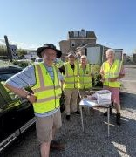
So, a huge well done to everyone who worked so hard in the hall and outside, not only the ‘gate guys’ who were there from 07.15 to let the eager traders in, to make this event such a huge success.
A CHAT WITH A GROUP OF THREE VISITORS
“We are Graham, Sharon and daughter Elsie. The car boot sale is great. Lots of people have turned out, which is really nice and we’ve got the good weather as well, which obviously helps. Last time we came it was really raining, but we still came. We really like the variety of stuff that’s here, especially the old vintage stuff.”
AND TALKING TO A COUPLE OF TRADERS
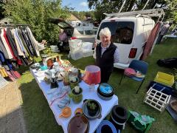
“I’m Sally Gregory, and I’m selling bric-a-brac, I’m having a de-clutter. I find these car boot sales are great, always lots of people coming, and we do quite well. The best thing about this event is that there are lots of willing helpers, support from the organisers, and the bacon rolls are very popular. Also, there’s lots of passing traffic (viz people past her stall). So, it’s really, very good.”
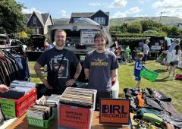
“We are Jordan from West Kilbride and Jack from Largs, and we are selling a mix of vinyl, DVDs and vintage clothing as well. Jack is also promoting his new furniture restoration business that he is trying to set up after graduating at college.
This is our first ever car boot, and it’s going really well, with a nice variety of people coming and going. It’s been super easy to set up. We arrived at about a quarter to eight, came straight in, easy setup, table was brought to us almost straight away. I like the community of people that come along, and I’ve seen some of them before at other car boots that we have been to as visitors. It’s nice to see people coming back and having a rapport with the stall holders, which is good for making connections and selling stuff on. It’s been run really well and it’s really nice to have the food and drink at the back to keep the people topped up and energised.”
Introducing . . . . . . . . .
Father Sean Joseph Jackson McEwan
b. 1989, Chattanooga Tennessee, USA

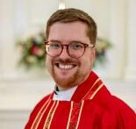
I am 37 years old and I was born in Chattanooga Tennessee. I have one brother, Austin, who is 3 years younger than me. My father was a college History Professor and my mother was a Special Education Teacher, I went to public school (state school) until I was thirteen and then went to a private High School in Chattanooga. I enjoyed both types of school, each had their good aspects, but I feel I had a better experience at the private school. I then went to the University of Memphis, in Tennessee, where I studied history and religious studies, graduating at the age of 28, as I had worked for 12 years in property / estate management in parallel with my university course. After university I went to the School of Theology, also known as the University of the South, at Sewanee, Tennessee, where I obtained my Master of Divinity degree.

My grandfather was a Baptist minister, and I was raised in the Baptist tradition, but moved over to the Episcopalian church when I was 20 years old, because I felt more at home with the liturgical and theological beliefs of the episcopalian church – they appealed to me a lot. I also felt very welcomed into the episcopal church and it encouraged me to explore my curiosity. I married Lance in 2014, and we had to elope to New York City, to be married in the courthouse there, as it was not legal at that time back in Tennessee.

What are the three happiest memories of my life? First my marriage to Lance in 2014; Second completing my seminary following ten years of discernment and preparation for ordination and spiritual development – being ordained was a real highlight; and third being called to St Columba’s in Largs – the anticipation of coming to Scotland is a great joy to me.

I think the Episcopal Church in the USA is very similar to the Scottish Episcopal Church, mainly due to the historical foundation of the Episcopal Church in the USA, which occurred in 1789, shortly after the War of Independence. Being so close to the tail of the American revolution, contact with English was taboo, and no English bishop would ordain our Bishop because he could not swear loyalty to the King. So our church turned to the Scottish Episcopal Church, and even though we were non-jurors (we did not swear an oath to the King), the Scottish Bishop ordained our first Episcopal Bishop in the USA.

Finally, I would like to say that I was strongly drawn to St Columba’s in Largs, especially due to the warmth of the people, the kindness and hospitality they showed towards me and Lance. It was so appreciated by us both. I am almost giddy with excitement at the prospect of living in Largs and ministering to your community – I look forward greatly to meeting and worshipping with you all. A small point – in the USA I’m known as Father Sean, maybe a remnant of the old tradition of the1789 Episcopal Church. I am very happy for you all to just address me as ‘Sean’.
POETS CORNER (anon)
The 4th of July flew over to Largs from
Chattanooga, came Sean and Lance
One Priest-in-charge new
And one husband tis true
They are here, our lives to enhance

Stars, stripes and St C
Two flags did we see
Fluttering high, tho the sky was not blue
For rain clouds were up there,
At the sky we did glare,
And the deluge near downed you and me

Yet inside our new hall
Barbequed meats for all
With salads, wine, beers, even fizz
And with our new friends
We celebrated and did bend
Our ears, talk talk talking, gee whizz

Scottish reels then broke out
And while dancing we did shout
For the fun of the day and for joy
As we raised the last toast
And made speeches guests and host
It was a great day for all, my boy.
BLAST FROM THE PAST
The following extracts are from a letter written in August 1976 by the Rev Canon D O Noble, who was the Rector of St Columba’s SEC at the time.

My Dear Friends
Congratulations to all who participated in the beginning of our Centenary Celebrations on July 30th and August 1st. It was a joy for us to have as our preacher at the Sung Eucharist of the Centenary of our dedication on the Sunday, our former Bishop Dr. Moncreiff. The number of communicants is the largest ever recorded since the Church was opened for worship 99 years ago.

The music was, of course, of the usual high standard, and the addition of our 2 boy trumpeters added to the glory and happiness of the occasion.

The church was superbly decorated for the Exhibition of Centenary Kneelers . . . . . . . obviously done by ladies who knew their craft. The font had two historic pieces in its adornment – a christening robe over 100 years old and child’s combined table and chair, which, I believe, elicited the enthusiasm of no less a person than Arthur Negus! The porch gave a depiction illustrating St Columba himself, with the symbolism of the seashore, the oar and the white dove. All excellent and appreciated!!

. . . . . . . . . . . . . . . . . The arrangement of the marquee and tents for the Summer Fête on the Saturday were set in the best we have ever experienced, due to the expert planning and assistance of Mr John Ellison. Those who turn up for the opening of the Fête cannot realise the stresses & strains, mental as well as physical, in erecting the tents and large marquee, especially as the tent pegs for the latter were not delivered! The great moment came when the warning horn of Mr Ian Jenkin’s Bently signalled the Brisbane Queen was approaching. . . . . . . . . . . . . . . . . It was a hectic afternoon, and the stalls were soon emptied. I was desperately sorry for those ladies and Girl Guides serving (“slaving at” would be better) teas in the Church Hall and the tiring heat. . . . . . . . . . . As someone remarked to me, “Your Fete is always a success, - whatever the sum of money you raise. Time and again I am told “What a friendly bunch you are”; and “It is a pleasure to be served by happy people, not only concerned with the commercial side.” We were indeed happy for the admirable sum of over £920 we raised.

Back to Sunday. All over town were plastered bills advertising a Centenary Concert in Church at 3pm on Sunday 1st August. . . . . . . . . The Church was packed for a wonderful musical presentation of worship and thanksgiving. Festal Evensong ended a glorious weekend of thanksgiving, remembering that day 100 years ago, when Mis Charlotte Aubery Arethusa Brisbane laid the first stone in the building that only ten months later became our beloved Church of St. Columba.

And so on to the next event in our Centenary year – on Friday 3rd September, an All Sorts Dance in the Church Hall. Have I missed you in my thank-yous? Forgive me. Perhaps it is the mounting excitement of having three free Sundays in Nova Scotia and New Brunswick.

May God bless you and yours
Your Sincere friend and Rector
D. O. Noble

Justice and Peace group
“faith by itself, if it is not accompanied by action, is dead” James 2.
This small ecumenical group meets in Largs about once a month. Composed of members from St Columba’s, St Mary’s Cathedral of the Isles, Brisbane Evangelical Church, and others, the purpose of the group is to bring to life the Gospel messages of Peace and Justice, through prayer and action. We share information about actions that are taking place, issues of concern, both locally and more widely. We are loosely connected to Justice and Peace Scotland and are kindly hosted by Father Peter at St Mary’s. If you are interested in joining with us, please contact Armorel (07734 888980) for dates of meetings.

Diary jottings

September : Anniversary Quizz, cheese & wine.

October : Artist’s talk on Sacred and Liturgical art.

November: St Columba’s choir will perform a special composition by Sir James MacMillan.
250 years ago across the sea
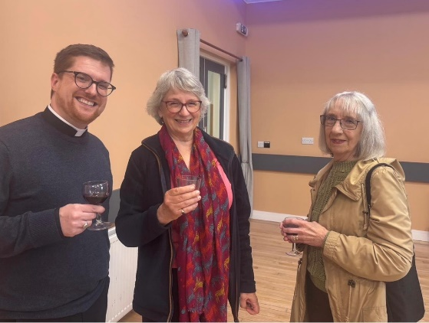
On a wet and windy Saturday in July, over forty people gathered is St Columba’s newly renovated church hall to welcome Sean McEwen and his husband Lance to Largs, after their epic 4,000 mile journey from Chattanooga, Tennessee. We also celebrated July 4th with them, it being the 250th anniversary of the United States of America winning its independence after a bitter eight year war with Great Britain.

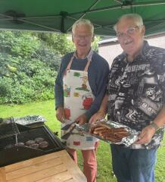
The Stars and Stripes proudly flew alongside St Columba’s SEC’s 150th year anniversary flag, the hall was bedecked with American and Scottish bunting, and a veritable abundance of American flags were seen on all the tables. A rich choice of pork ribs, sausages and burgers were provided by team BBQ, tables were laden with salads, side dishes and delicious puddings. Prosecco, wine, beer and soft drinks flowed. A delectable feast was enjoyed by all.

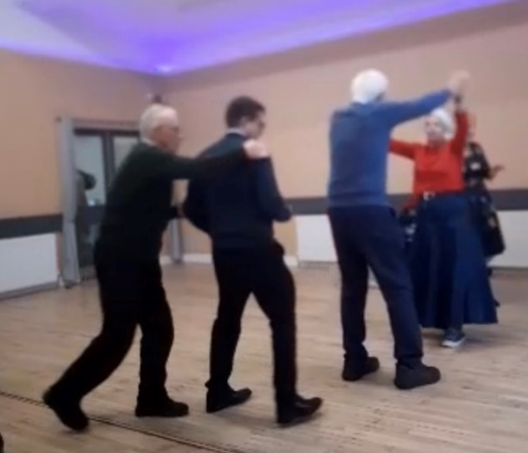
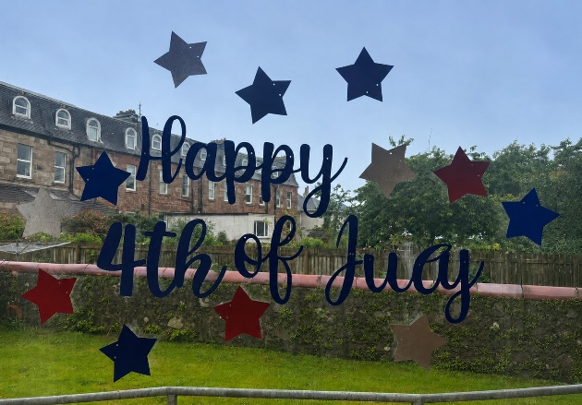

And the celebrations continued after the meal with Scottish Country dancing, led buy our one and only Frances Muir. Sadly, the croquet and boules had to be cancelled due to the inclement weather. C’est la vie – welcome to Scotland Sean and Lance!

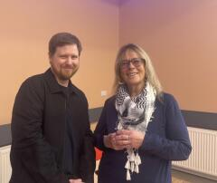
July 4th 2026 was a wonderful opportunity for the congregation of St Columba’s SEC to welcome their new ‘Priest-in-Charge’ and his husband Lance to Scotland, Largs and St Columba’s SEC, which will be their new home and place of work for the next five years. It was also a great opportunity for them both to informally meet and get to know their future parishioners.
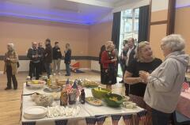

It was a great day. A huge thanks to all members of the church who worked tirelessly to make the celebration an outstanding success.

At the end of the day, Lance kindly and warmly thanked everyone for a great afternoon.
Life at St Columba’s
Priest-in-Charge
Father Sean McEwen 07951 181827

Director of Music
Colleen Anderson 07967 114624

Property Convenor
Mark Yeomans 01475 520296

Fundraising Committee
Hilary Moran 01475 686213

Protection of Vulnerable Groups Co-ordinator
Victoria Johnston 07961 762973

Mother’s Union
Hilary Moran 01475 686213

Church Hall Convenor
Linda Young 01475 686241

Church Flowers
Joan Hutton 01475 672927

Sidesmen
Alice MacDonald 07833 120400
Jennifer FitzGibbon 01294-823992

Christian Aid
Alice MacDonald 07833 120400
Reps on inter-church Christian Aid Committee

Intercessions Rota
Frances Robertson 01475 686947

Altar Servers
Alice MacDonald 07833 120400

Readers Rota
Gib FitzGibbon 01294 823992

Coffee Rota
Jennifer FitzGibbon 01294-823992

Press Officer
Hilary Moran 01475 686213

Magazine Editor
Robin Spencer 07818 035789

Health and Safety Officer
Alice MacDonald 07833 120400

Baptism, Wedding, Funeral, Confession by arrangement with the Rector

Largs & District Churches Together Reps
Alice MacDonald 07833 120400
Armorel Allen 07734 888980

Pastoral Visitors in the congregation
Rector (to be appointed), Alice MacDonald, Linda Whitby and Armorel Allen
A new anthem for St Columba

Bishop Nick posted an article in his Diocesan Newsletter, which is printed below, about Sir James MacMillan’s new anthem that Sir James has composed and dedicated to St Columba’s Church, Largs, to contribute to its 150th Anniversary Celebrations this year.
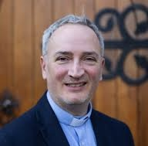

Let us sing a new Song : A New Anthem for Largs

“St Columba’s, Largs, is celebrating its 150th Anniversary this year, and as part of the Celebration, Sir James MacMillan has composed a new anthem for the church choir. The anthem, based on the Beatitudes, will receive its première on All Saints Day, 1 November, at a Eucharist of Thanksgiving at which Bishop Nick will preside.

Colleen Anderson, Director of Music at St Columba’s said she was ‘more than honoured’ to share the news, having received the composition from Sir James along with his gift of multiple music scores. Sit James has also led the first choir rehearsal, and the choir – along with friends – how begin the serious and joyful work of preparing the piece for its first performance.”

James Willetts reflects

“Going back from Seamill to Stratford-upon-Avon, after a very celebratory couple of weeks at St Columba's, was an interesting prompt for reflection. The Patronal Festival, marking the 150th anniversary of the founding of our church in Largs, followed by the installation of Father Sean, and a few days later his first service, were all happy events. But it's interesting sometimes to stand back and view things from a distance. Looking back at this convivial and positive period, I'm struck by how important is the relationship between church and community. St Columba's in Largs is very good at this - and even more so now that the Church Hall has been refurbished.”

SERVICES & FUTURE EVENTS
Weekly Services
Sunday
8.00 am Holy Communion
11.00 am Sung Eucharist
Wednesday
10.00 am Holy Communion
September
7th September Taizé (5.00 pm)
16th September Vestry Meeting
19th Sept, 7pm Anniversary Quizz, cheese & wine
20th September Vestry Finance Meeting
20th September Big Sing L&DCT St Mary’s RC Church
October
3rd Oct. 2.00pm Blessing of Animals Service
4th October Harvest Festival Lunch
10th Oct, 7pm Artist talk on Sacred/Liturgical Art
11th October Taizé (5.00 pm)
17th October Holiday Club
25th October Congregation AGM, soup and roll
November
1st November Eucharist of Thanksgiving and World Premier of Sir James MacMillan’s new Composition
11th November Vestry Meeting
15th November Winter Magazine - copy deadline
THE HALL’S BIG CLEAN UP
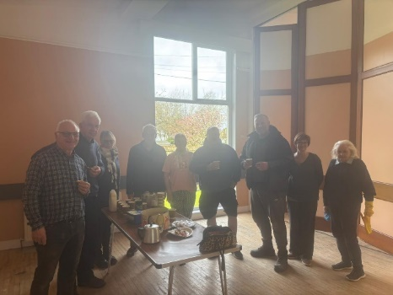
A team of church members assembled in the church hall on Saturday 11th April and worked hard to clean off the dust that had settled everywhere following the storm repair works undertaken by contractors Steven Gough and Co. Radiators were wiped, doors and wall dados were carefully cleaned, floors were swept and mopped, the kitchen was given a complete overhaul – even the blinds were given an individual wipe clean.

Sadly, we didn’t use the hall for the car boot sale as it was still technically ‘a building site’ and could not be used til the works have all been completed, in order to avoid problems with our insurance.
The Scottish Episcopal Church

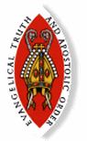
The Scottish Episcopal Church is a self-governing province of the world-wide Anglican Communion.

This is a family of over 70 million Christians in more than 160 countries. Our nearest relations are the Church of England, the Church of Wales and the Church of Ireland. Through the Porvoo agreement we are also in full communion with many other branches of the Church.

St. Columba’s in Largs, is one of over 60 Episcopal congregations that work and worship within the Diocese of Glasgow and Galloway. We are part of Ayrshire Region and our neighbours include congregations in Ardrossan, Dalry, Troon, Kilmarnock, Prestwick, Ayr and Maybole.

The area covered by St. Columba’s includes Largs, Skelmorlie, Fairlie and West Kilbride. Ecumenically we play a very active part in Largs and District Churches together. We welcome all regardless of any defining characteristic that may otherwise be used as the basis for discrimination.

Church Rotas

If you would like to join one of the church rotas (Readers Rota, Intercessions Rota, Sidesman Rota or the Coffee Rota), please contact :

Readers Rota – Gib FitzGibbon 01294 823992
Intercessions– Frances Robertson 01475 686947
Sidesmen – Alice MacDonald 07833 120400
Coffee - Jennifer FitzGibbon 01294 823992
Email – i2fg@aol.com
St. Columba’s Episcopal Church
Aubrey Crescent, Largs
Priest in Charge : Father Sean McEwen
St. Columba’s Church, Largs
Telephone - 07951 181827

The Vestry
The vestry members are elected by the congregation to work with the Rector for the administration of the church. It meets in January, March, September, November and as required.

Chair – Father Sean McEwen
Secretary – Ray Young
Treasurer – Chris Evans
Lay Representative – Gib Fitzgibbon
Alternate Lay Rep – Hilary Moran
Rector’s Warden – Linda Young
PVG Co-ordinator - Victoria Johnston
People’s Warden – Alice MacDonald
Property Convenor – Mark Yeomans
IT Services - Gregor Anderson
Members - Linda Whitby, Jane McCance and Thomas Parker

Scottish Charity Number – SC004796

Sean McE - a licence to heal

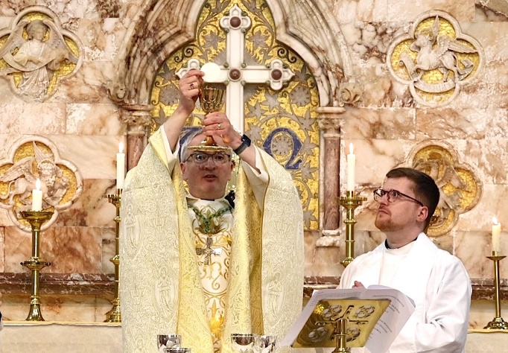

Clergy from across the Diocese of Glasgow and Galloway, with local church representatives, civic leaders and many members of St Columba’s congregation, gathered at St Columba’s SEC to witness Bishop Nick license Rev Sean McEwen as the new Priest-in-charge. A truly moving and joyous occasion for all. Sean now has his license to heal – to heal souls in need of comfort and love.
Diocese of
Glasgow and Galloway
49 Cochrane Street, Glasgow G1 1HL
0141 221 5720
Diocesan website:
http://glasgow.anglican.org

Key contacts
Bishop
The Right Reverend Dr Nick Bundock
bishop@glasgow.anglican.org

Bishop’s Personal Assistant
Alexis Costigan
alexis@glasgow.anglican.org

Enquiries regarding property matters
usual days Monday to Wednesday
Janet Chalmers
janet@glasgow.anglican.org

Enquires regarding Finance
Monday, Wednesday, Thursday, Friday
Iolanthe Stack
iolanthe@glasgow.anglican.org

Diocesan Secretary & Treasurer
Susan Burr
diocesansecretary@glasgow.anglican.org

Director of Diocesan Operations
TO BE APPOINTED
usual days
Monday, Wednesday, Thursday, Friday
da@glasgow.anglican.org

B, B, C, M, D in 2025

….. from the Church Register for 2025:

Baptisms
Connor Docherty 20th April 2025

Funerals
Freddie Moran 4th February 2025
Chris Howe 27th February 2025
May Kidd 27th May 2025

The church magazine is printed and published by St. Columba’s Episcopal Church, Aubrey Crescent, Largs, KA30 8PR. The views expressed in this magazine are not necessarily those of the Rector or the Vestry. If you know of anyone who cannot access the online version at https://largs-church.co.uk/magazines or collect it from church, we can arrange for a copy to be sent to them.

