
SPRING EDITION 2026
Issued 22nd February 2026


Spring and Easter traditions

Easter traditions have roots in both Jewish and Christian (resurrection) observances. In addition, many modern customs also blend ancient pre-Christian, pagan symbolism for spring and rebirth.

Pre-Christian ideologies of resurrection
The pre-Christian, ancient world is filled with stories of resurrection around spring. 2,000 years before Christ, the Sumer who lived in southern Mesopotamia (Irak), inscribed a story of their goddess Inanna onto a clay tablet, descending into the underworld to find her recently deceased husband, where she was killed, then brought back to life. She was permitted to return to the world as the sun for 6 months then had to descend into the underworld during the winter for 6 months. Other stories that share ideologies about renewal and light conquering dark are the resurrection of Horus, the Egyptian falcon-headed deity and the death and rebirth of the Greek god Dionysus.

Christian Easter
The celebration of spring and renewal of life is a concept rooted in paganism. As Christianity swept across Europe, many pagan festivals and traditions were absorbed into the Christian faith. It made sense that the ingrained concept of new life being celebrated during springtime should become associated with Jesus conquering death and being reborn. But the date of Easter falls on the Sunday following the first full moon after the spring equinox, not a specific date on which Christ was said to have risen from the dead.
Other traditions - bunnies, buns and eggs
Rabbits and hares are ancient symbols of fertility and life, but it took until the 17th century before a German tradition about an Easter hare, known as the Osterhase, which delivered eggs to good children, caught on. The softer looking bunny replaced the hare as the tradition spread across the U.S. via German immigrants during the 1700s.

Eggs were also symbols of new life and fertility in various ancient cultures. As Christianity absorbed pagan spring traditions, the ‘Easter’ egg was also adapted to become the perfect representation of Jesus’ resurrection; the eggshell symbolising the tomb, whilst the cracking of it representing Jesus’ emergence; life-conquering death.

Hot cross buns, that are said to symbolise the crucifixion of Jesus, are also thought to have pagan origins. Pagans celebrated Ēostre, by baking buns marked with a cross (representing the four primary phases of the moon and the four seasons) to celebrate the springtime goddess.

'Easter'. Some historians argue the word derives from a pagan springtime goddess called Ēostre, who is documented by an Anglo-Saxon monk who wrote during the 8th century AD. Ēostre was a goddess celebrated with a festival during the spring equinox and according to some scholars, her association with hares is the origin of the Easter Bunny story.

What’s on in this issue

Page 1 Spring and Easter traditions
Page 2 Editors notes, the Interim Rector writes
Page 3 Building St. Columba’s church
Page 4 Book review and Poet’s corner
Page 5 Early saints pilgrimage plan
Page 6 Church organ, Life at St Columba’s
Page 7 Future services / events and other notices
Page 8 Vestry details, key contacts, other news
A note from the editor
I welcome any feedback on the style and content of your church magazine, as well as any articles, news items or poems that are special to you.

The COPY DEADLINE for the Summer edition of the church magazine is 15th May 2026.
Robin Spencer, Editor
How to contact me
Letters Holehouse Farm
Holehouse Road, Largs, KA30 8RL
Email: robin@shropshirelavender.co.uk
Social Media Whatsapp message me direct
(Robin Spencer on the mobile number below)
Telephone / text 07818 035789

What’s on in future issues
The next magazine will be the Summer issue, with a focus on long, hot summer days, holidays and the pilgrimage to celebrate Saint Columba.
Please email me a photo of any places in Scotland of particular beauty, interest or meaning to you, with a brief explanation of what it means to you.
The church WhatsApp group
St Columba’s Episcopal Church has a very active social media group on WhatsApp, where we share reminders, raise and answer queries, and broadcast information (such as progress on the church hall repairs).

If you wish to join the WhatsApp group, please message Hilary Moran on 07989 693410

New rector – latest update
At the end of the third round of advertising, Vestry is aware of only one (slightly complicated) application and has asked the Bishop for guidance how to handle the application, whether we should re-advertise now or after a break, and if he is aware of any other potential applicants. Vestry will keep you informed of the next steps.
The Interim Rector Writes
Dear Friends
As we begin our journey through Lent, Holy Week and Easter it is good to remind ourselves of this important journey in our lives. If someone was to ask you how important Lent was to your faith it might surprise you that Lent is the one which has least impact on our lives.

Lent is the beginning of a journey to a joyful Easter Day which offers us a more glorious reference towards a new life. The church should be a family of people sharing the good news that we've been informed of the greatest story of all, which we've taken as gospel, and because of that acceptance we have the opportunity to look at the world as God sees it. That means we look at the world with love and optimism. God looked at his world and saw that it was good despite everything humanity tried to do. I reckon God still thinks that way. At the same time we must not be blinded to the difficulties in our communities and our own lives.

The Swiss theologian Karl Barth said a Christian should be someone who carries the Bible in one hand and a newspaper in the other. In other words, they have to be people who listen to God's voice and apply it to where we are now, not where we once were or where we would like ourselves to be. We have to be heavenly minded but we also have to be of some earthly use. It's not an easy balance to strike. I guess Lent is as good a time as any to reflect on how we approach these issues.

As we approach the most critical of weeks, Holy Week, may we reflect upon how far we can truly engage with the world not simply as a means of changing it but how our openness to serve that world may be a time of renewal and encouragement for each of us. May Easter Blessings be with you all at St Columba’s.

Canon Sandy
Vestry Meeting - Snippets
- The Province awarded us £5,440 towards insulating the hall roof
- Vestry decided to purchase a defibrillator to be available for public events, and in parallel Linda Young will arrange Heartstart training for sidesmen and volunteers
- The first car boot sale this year will be held on 18th April.

Building St Columba’s Church

Commemorating the 150th Anniversary of the Dedication of St Columba’s
In 1848 members of the Episcopal Church in an around Largs commenced Sunday Services in a room of the Brisbane Hotel until an empty Relief Presbyterian Church was purchased. The building (later developed as the Sandringham flats) was a “square, unadorned edifice, and destitute of all claims to Ecclesiastical Architecture” and soon became unsuitable for an increasing congregation “being composed largely of the working classes, persons of small income and numbering about 70 Communicants”.
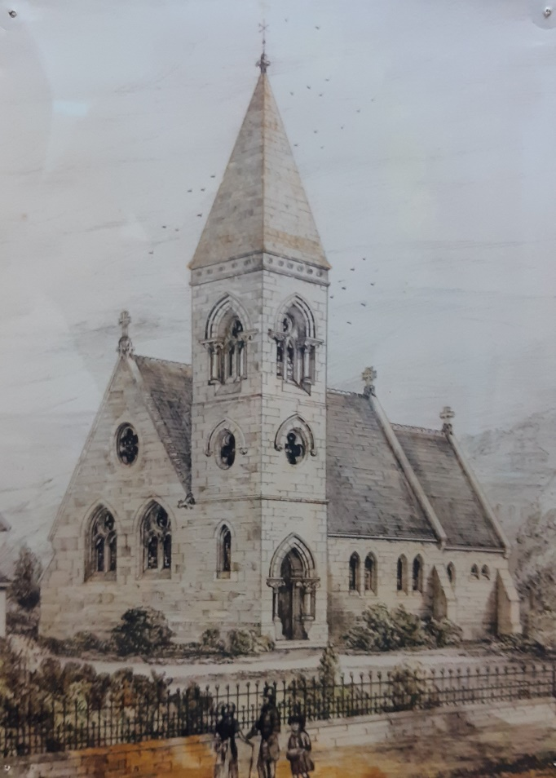
In 1876 Ms Charlotte A A Brisbane of Brisbane House gave from her Estates the present site at Aubery Crescent for a larger church and Rectory. An appeal for funds was launched to raise the estimated cost of £2,000 to which the Earl of Glasgow gave £500 plus the income from the sale of the old Church premises.
The new Church was designed by Messrs Ross and McBeth of Inverness in the Early English Style, but a proposed belfry tower was never built.

Dedicated at the laying of the foundation stone by Ms Brisbane on 2nd August 1876, the Church was consecrated, appropriately, on Saint Columba’s Day, 9th June 1877 by the Bishop of Glasgow with a large company of the Episcopal Clergy and the Earl and Countess of Glasgow in attendance.
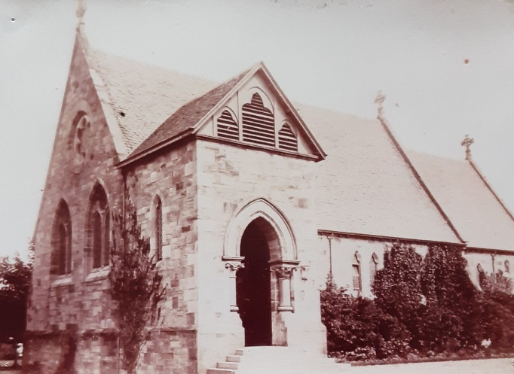
Stone for the Church came from Auchencharry quarry with the walls lined with red sandstone from Skelmorlie. The Reredos, the ornamental screen behind the altar, is composed of alabaster and various kinds of marble and the font is made of stone from Brora with the basin resting on a shaft of Peterhead granite. The windows were supplied by Messrs Heaton, Butler and Bayne of London. Alexander Ross of Inverness was the architect and the work was executed by R. Snodgrass, mason; D. Boyd, joiner; S. Stewart, slater; T. McKirdy plumber and Joseph Walker, painter.
The newly established Largs and Millport Weekly News of 9th June 1877 commented that “The effect of everything is most pleasing, and the efforts of those who have done so much to beautify this house of God deserve the warmest commendation. What with a comfortable church, magnificent accessories, and “Storied windows richly dight casting a dim religious light” it must be a pleasant thing to be regular in attending to the ordinance of religion.”
The first Rector, Rev. C. M. Keith, served from 1868 to 1880 to be followed by Rev. Canon W. L. Low from Cruden Bay whose “pawky sense of humour” spanned 41 years, from 1880 to 1921.
Many thanks to Ray Young for writing this article.
BOOKEND REVIEW
NARZISS AND GOLDMUND
By Hermann Hess

Narziss is a monk and teacher at Mariabronn Monastery in Medieval Germany. Brilliant and severe, he fears his favourite pupil will become neither a scholar or a monk. Goldmund accepts his fate lies not in a monastery. This book addresses how Goldmund lives a very ‘wordly’ life becoming a master wood carver, always regretting he failed to live up to his ‘hero’ Naziss’s expectations. However, on his deathbed he is astonished to learn that Narziss, now Abbot of Mariabronn, has a deep respect for the life he led and is also a bit jealous.

EXTRACT (from chapter 5)
The school, the courtyard, the dormitory, the library, the cloister chapel, had become only the surface of reality, a trembling outer film, encasing the image world of dreams, the deep intensity of life . . . . . . . . . . . . . . . . .

Goldmund never told all this to Narziss, only now and then would he hint of it. “I believe,” he said to him once, “the cup of a flower, or a little, slithering worm on a garden path, says more and more to hide, than all the thousand books in a library. Often, as I write a Greek letter, theta or omega, I have only to give my pen a twist, the letter spreads out, and becomes a fish, and I, in an instant, am set thinking of all the streams and rivers in the world, of all that is wet and cold, of homer’s sea and the waters on which Peter walked to Christ. Or else the letter becomes a bird, grows a tail, ruffles out his feathers, and flies off. Well Narziss, I suppose you think nothing of such letters. But I tell you this: God writes the world with them.”

I esteem them highly, said Narziss sadly, “they are magic letters, and every dream can be conjured up with them. But, alas, they cannot be used for learning sciences. Thought loves definitions, and clear forms, it needs to be able to trust its signs for things : it likes what is, and not what is to be, and so it cannot bear to call an omega snake or a theta bird. Now, Goldmund, do you believe what I told you, that we should never turn you into a scholar?

Oh yes, Goldmund had long since agreed with him, and long since known himself resigned to it.
“I no longer care to strive after your learning,” he said almost with a laugh, “and I feel now for all learning and intellect what once I used to feel for my father. I used to think I loved him very dearly, hoped that I’d made myself like him, and swore by everything he said. But my mother came back, to show me what true love is. Beside her image my father’s memory shrank to nothing. It displeased me; I came near hating it. And now I almost think that all learning is like my father; and has no love in it, and so I begin to despise it a little.

Though he jested in saying all this he could not bring any smile to his friend’s sad face. Narziss studied him in silence, his glance almost a caress. Then he said : “I understand you well. Now we have no need to dispute.” . . . . . . . .

Now there was only one thing left that mattered : the wild beating of Goldmund’s heart, an anxious pricking of desire in him, the joy and terror of his dreams. To these he now belonged and let them master him. In class, he seemed to study, but could sink down into himself, forget his fellows, plunge through the murmuring torrent in his heart, and let its current swirl him away with it; into deep pools echoing with dark music, clouded depths of fairy sounds and happenings, all calling him with the voices of his mother, their thousand eyes his mother’s eyes.

If you enjoyed this excerpt from my favourite of all books, and would like to read it, get in touch.
I have a spare copy you can borrow. Ed.

POETS CORNER (anon)

Plop. Plop. Plop, the trees dripped ever wet
And the icy North wind cut to the bone, yet
Snow and slush were now gone from the lane
And wee birds were lilting their songs yet again

And suddenly one joyful morn in May
The sun beamed bright over Largs, all day
And people emerged from their winter shells
And churches rang loud their dongly bells

For Spring was vibrant across field and moor
Life had returned to this Scottish shore
And smiles on the faces said all to be said
The dread gloom of winter was finally dead.
Early Saints Pilgrimage
Journeying together in Faith, by Hilary Moran
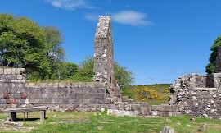

I’m excited to share our plans for an early Saints Pilgrimage in celebration of our church’s 150th anniversary. Our journey to the Isle of Bute, alongside the spirit of St. Columba, will allow us to explore the rich history of early Christianity.
We’ll visit the serene and remote St. Blane’s Chapel, a place that holds deep significance. In fact, Mark Yeomans, the former captain of the ferry from Rothesay, shared that after his working day, he would often find peace and solace at St. Blane’s. It truly is a special place that brings a sense of calm and reflection.

This pilgrimage isn’t just a day trip; it’s an opportunity to create meaningful memories and foster community. It’s a time for reflection, prayer, and meaningful conversation, especially for those of us who are navigating life as widows/widowers or members on their own.
I believe this pilgrimage will be a beautiful and enriching experience for our church family, helping us grow closer together and reflect on our shared spiritual journey.

To sum up, we’ve got a Friday itinerary with the ferry ride, hotel check-in, a possible visit to Mount Stuart, or free time. Meeting late afternoon for a reflection on the early Saints, group dinner and evening prayers.
Then on Saturday, day trip members join us off the ferry and we all proceed to St Blanes Chapel, where we hold a Eucharist service followed by a picnic or group lunch at a hotel. In the afternoon the Spiritual leader could lead on some reflections before heading back to the 5pm ferry.

Hilary
Journeying Together in Faith

The vestry has approved the proposal and now we are asking all the congregation to decide if they would be free/like to attend. The proposal would need a minimum number of people , so we are asking for those interested to say so by Sunday 8th March. If sufficient numbers are interested and physically able to do the short walk, we would start looking for a spiritual leader.

PROVISIONAL ITINERARY
Friday 12 June – Saturday 13th June

Option 1 to stay overnight Friday
Friday 12th Arrive by ferry 09.05 Wemyss Bay arrive Rothsay 09.40 in shared cars. Get to hotel/accommodation/ leave luggage. Meet for prayers in room put aside. Option to have a group tour of Mount Stuart or free time
Mid afternoon meet for a talk on the Early Saints. Reflection before or after group dinner. Compline?

Option 2 Day Trippers
Saturday 13th Day visitors arrive by ferry 09.05 Wemyss Bay arrive Rothsay 09.40 in shared cars. Everyone makes their way to St Blanes Chapel a 25 minute drive + slow 15/20 minute walk to the chapel. Room for 6 cars to park.
11am Eucharistic service starts in the ruined chapel. Time to walk in the area/ flexible
12.30pm Leave and go for lunch together at hotel or a picnic at 1pm
2pm – 4pm Journey reflection
5pm Catch the 17.00 ferry Rothsay arriving at 17.35 at Wemyss Bay

Travel and accomodation notes
Glenburn Hotel
Dinner Bed Breakfast £140 sole occupancy £175 twin/double room
Room hire £50 per day
Car of 5 people - ferry return £71.90 (£14.40 pp)
We have permission from Historic Scotland to hold a service, and Laura Miller will ensure there isn’t any works going on at that time.
.
The Church Organ
The church organ needs a thorough overhaul, as parts are worn, there are problems with leaks, rust, dust, dirt accumulation and tuning.

MacDonalds, a Glasgow firm of excellent reputation in organ maintenance (but none in cooking hamburgers), has submitted a comprehensive report on our organ, together with a proposal for a thorough overhaul which would restore it to a condition that will enable it to reach its full potential, together with a 20-year guarantee, at a cost of £15,680.

The Vestry considered several options and took the view our organ is an integral part of our church and our worship and should be preserved. It is one of the oldest of its type in Scotland having been installed in 1882. Vestry therefore decided to accept Macdonald’s proposal, which we can afford from our reserves, thanks to Ken Hinshelwood’s generous bequest. However, if any church members would like to contribute to the restoration costs, please contact Chris Evans.

Work is expected to start on 16th February and be completed in around five weeks, well before Easter. Services will continue in the church, but some rearrangement will be necessary to allow working space around the organ.
Church hall repairs – progress!
Repairs work to the church hall picked up a pace in the New Year. Hall roof repairs and insulation are 80% complete, walls 65%, floor 0% and storeroom 60%, so overall the hall is about two-thirds done (as of 15th February). Our thanks go to the contractors Steven Gough and Co, who have really worked hard, once the insurance company gave the go ahead, and we confidently (fingers crossed) look to be on target for re-opening the hall by Easter for church goers and other hall users.

Work on the kitchen and toilets will commence once the hall is reopened.
Treasurer’s tales
3 stained glass windows damaged in January 2025 by storm Eowyn are refurbished, back in place. The dove window is also strengthened.
The insurance company will only replace old for new, extra work is funded by the church.
Life at St Columba’s
Director of Music
Colleen Anderson 07967 114624

Property Convenor
Mark Yeomans 01475 520296

Fundraising Committee
Hilary Moran 01475 686213

Protection of Vulnerable Groups Co-ordinator
Victoria Johnston 07961 762973

Mother’s Union
Hilary Moran 01475 686213

Church Hall Convenor
Linda Young 01475 686241

Church Flowers
Joan Hutton 01475 672927

Sidesmen
Alice MacDonald 07833 120400

Christian Aid
Alice MacDonald 07833 120400
Reps on inter-church Christian Aid Committee

Intercessions Rota
Frances Robertson 01475 686947

Altar Servers
Alice MacDonald 07833 120400

Readers Rota
Gib FitzGibbon 01294 823992

Coffee Rota
Jennifer FitzGibbon 01294-823992

Largs Churches Together
Alice MacDonald 07833 120400

Press Officer
Hilary Moran 01475 686213

Magazine Editor
Robin Spencer 07818 035789

Health and Safety Officer
Alice MacDonald 07833 120400

Baptism, Wedding, Funeral, Confession by arrangement with the Rector

Pastoral Visitors in the congregation
Rector (to be appointed), Alice MacDonald, Linda Whitby and Armorel Allen

Diary jottings

June : Early Saints Pilgrimage to Bute.

October : Artist’s talk on Sacred and Liturgical art.

November: St Columba’s choir will perform a special composition by Sir James MacMillan.
SERVICES & FUTURE EVENTS
Weekly Services
Sunday
8.00 am Holy Communion
11.00 am Sung Eucharist
Wednesday
10.00 am Holy Communion
March
1st March Taizé (5.00 pm)
4th March Lent lunches, parish hall, 12.00-1.30
5th March Lent study course, West Kilbride
6th March World prayer day, ch of Nazarene
11th March Lent lunches, parish hall, 12.00-1.30
12th March Lent Study, 7pm, 12 Charles Street
18th March Lent lunches, parish hall, 12.00-1.30
19th March Lent Study, 7pm, 38 Railles Avenue
25th March Lent lunches, parish hall, 12.00-1.30
26th March Lent Study, 7pm, 17 Castlebay Court
29th March Palm Sunday L&DCT parish church 7pm
April
2nd April Maundy Thursday service, 7pm
3rd April Good Friday Walk of Witness, 10am
Meditation, St Columba’s, 2pm
5th April Early Easter Promenade Service, 8am
Easter Day festival of events
12th April Taizé, 5pm
18th April Car Boot sale with organ recital
May
3rd May Taizé (5.00 pm)
13th May Christian Aid Quiz, Parish hall, 7pm
16th May Christian Aid tea, Fairlie church, 2pm
23rd May Car Boot sale with organ recital
31st May Christian Aid s’vice Fairlie church 5pm
Christmastide ‘at home’
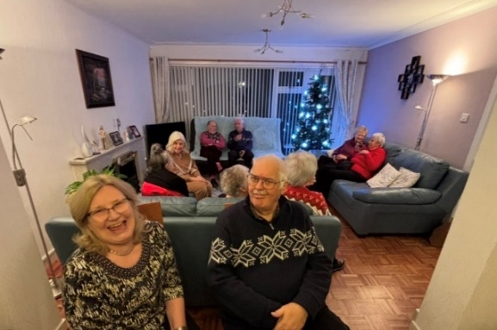
Members of St Columba’s church enjoyed a relaxing and enjoyable pre-Christmas ‘at home’, socialising with other church members, chez Alice MacDonald, who kindly hosted the event. Many thanks to Alice, our resplendent hostess.
The Scottish Episcopal Church

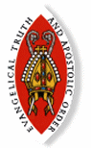
The Scottish Episcopal Church is a self-governing province of the world-wide Anglican Communion.

This is a family of over 70 million Christians in more than 160 countries. Our nearest relations are the Church of England, the Church of Wales and the Church of Ireland. Through the Porvoo agreement we are also in full communion with many other branches of the Church.

St. Columba’s in Largs, is one of over 60 Episcopal congregations that work and worship within the Diocese of Glasgow and Galloway. We are part of Ayrshire Region and our neighbours include congregations in Ardrossan, Dalry, Troon, Kilmarnock, Prestwick, Ayr and Maybole.

The area covered by St. Columba’s includes Largs, Skelmorlie, Fairlie and West Kilbride. Ecumenically we play a very active part in Largs and District Churches together. We welcome all regardless of any defining characteristic that may otherwise be used as the basis for discrimination.

Church Rotas

If you would like to join one of the church rotas (Readers Rota, Intercessions Rota, Sidesman Rota or the Coffee Rota), please contact :

Readers Rota – Gib FitzGibbon 01294 823992
Intercessions– Frances Robertson 01475 686947
Sidesmen – Alice MacDonald 07833 120400
Coffee - Jennifer FitzGibbon 01294 823992
Email – i2fg@aol.com
St. Columba’s Episcopal Church
Aubrey Crescent, Largs
Interim Rector: Sandy Montgomerie
St. Columba’s Church, Largs
Telephone – 07950 737277

The Vestry
The vestry members are elected by the congregation to work with the Rector for the administration of the church. It meets in January, March, September, November and as required.
Chair – Gib FitzGibbon
Secretary – Ray Young
Treasurer – Chris Evans
Lay Representative – Gib Fitzgibbon
Alternate Lay Rep – Hilary Moran
Rector’s Warden – Linda Young
PVG Co-ordinator - Victoria Johnston
People’s Warden – Alice MacDonald
Property Convenor – Mark Yeomans
IT Services - Gregor Anderson
Members - Linda Whitby, Jane McCance and Thomas Parker
Scottish Charity Number – SC004796

New Year lunch

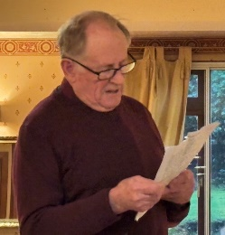
Members of St Columba’s Church gathered at the Willowbank Hotel after the sung Eucharest service on Sunday 4th January, for our traditional New Year’s lunch.

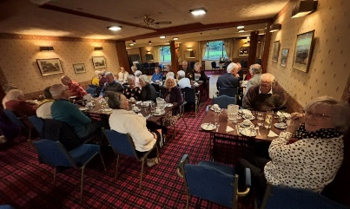
After a very fine meal, members of the congregation gave spirited renditions of their favourite poems, including some written by themselves.

The church magazine is printed and published by St. Columba’s Episcopal Church, Aubrey Crescent, Largs, KA30 8PR. The views expressed in this magazine are not necessarily those of the Rector or the Vestry. If you know of anyone who cannot access the online version at https://largs-church.co.uk/magazines or collect it from church, we can arrange for a copy to be sent to them.
Diocese of
Glasgow and Galloway
49 Cochrane Street, Glasgow G1 1HL
0141 221 5720
Diocesan website:
http://glasgow.anglican.org

Key contacts
Bishop
The Right Reverend Dr Nick Bundock
bishop@glasgow.anglican.org

Bishop’s Personal Assistant
Alexis Costigan
alexis@glasgow.anglican.org

Enquiries regarding property matters
usual days Monday to Wednesday
Janet Chalmers
janet@glasgow.anglican.org

Enquires regarding Finance
Monday, Wednesday, Thursday, Friday
Iolanthe Stack
iolanthe@glasgow.anglican.org

Diocesan Secretary & Treasurer
Susan Burr
diocesansecretary@glasgow.anglican.org

Director of Diocesan Operations
Kim Schmulian
usual days
Monday, Wednesday, Thursday, Friday
da@glasgow.anglican.org

Spring clean at St Columba’s
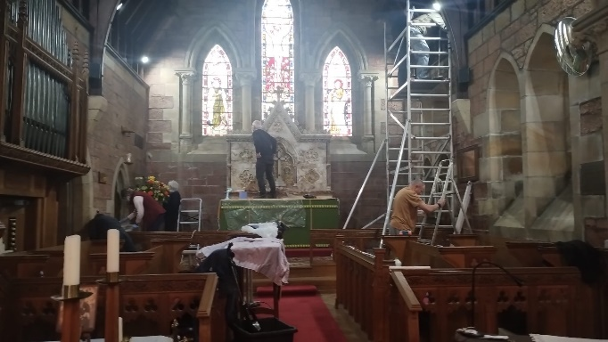
Warm thanks to the church members working group that did a splendid job at the beginning of February, cleaning the longitudinal beams around the organ (before its overhaul), rejuvenating the altar and removing loose stonework dust.

